
Department | FED
Subject | DSA-2
Academic Year | I-III Semester (2025-26)
Faculty Name | RAZIA BANU
Student Name | P SHASHE PREETHAM
Roll Number | 2520030534
Branch | CSE
Course Outcome | CO3

Case Study Topic: Airline Connectivity Analysis using DSU Rollback (Set 9 Q3)
Work Done Summary:
In this case study, we implemented a Disjoint Set Union (DSU) with Rollback to analyse connectivity in an airline network. Airports were represented as vertices and flight routes as graph edges. Union-by-Rank was used to merge connected components efficiently. A rollback mechanism was implemented to restore previous graph states after processing each query. Connectivity results were compared before and after the removal of routes. The implementation demonstrated the effectiveness of DSU Rollback for dynamic connectivity problems in transportation networks.

Implementation Details:
- Implemented parent and rank arrays.
- Applied union-by-rank.
- Stored rollback history.
- Restored graph state after rollback.
- Compared with BFS/DFS approach.

Result: Screenshots / Output
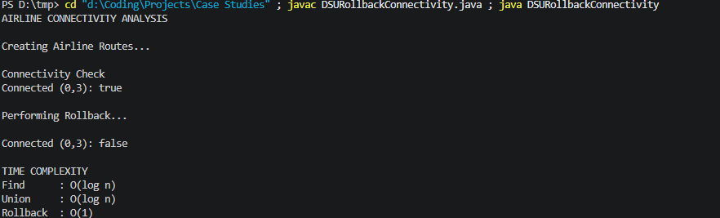
Connected (0,3): true
After Rollback
Connected (0,3): false
Time Complexity:
Find: O(log n)
Union: O(log n)
Rollback: O(1)

GITHUB LINK : https://github.com/tanyasri1405/DSA---case-studies-3.git

Student Signature | Faculty Signature

